**Technical Documentation – Twin Cities**

Database design and implementation

Initial design (Logical ER model):

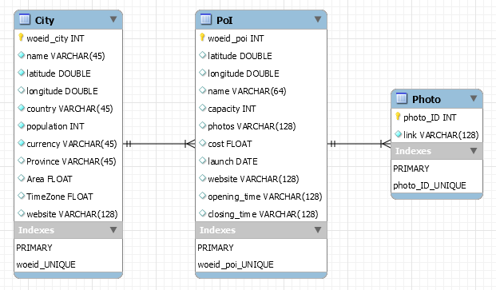

db_twincities:

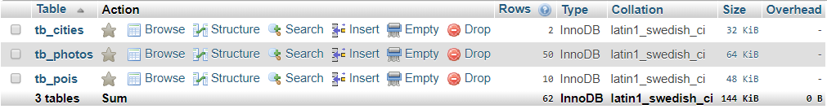

tb_cities:



tb_photos:

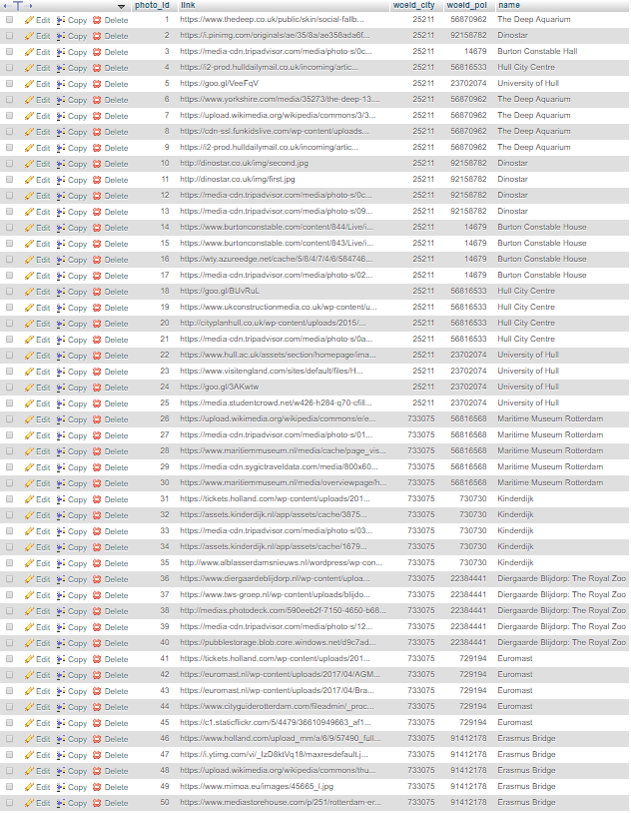

tb_pois:

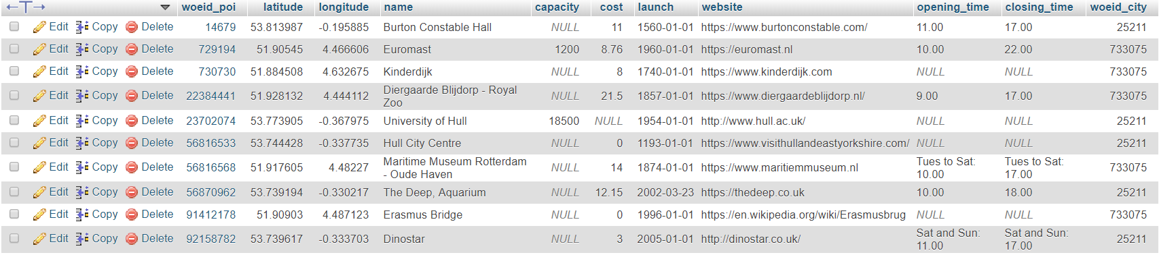

API usage

**Maps - OpenLayers API**

Used in index.php, rotterdam\index.php, hull\index.php

<https://cdn.rawgit.com/openlayers/openlayers.github.io/master/en/v5.3.0/build/ol.js>

The OpenLayers API consists of:

* names and signatures of constructors
* names and signatures of instance methods and properties
* names and signatures of functions
* names of constants

**Hull Weather -** [**http://www.ewwa.net/wx/clientraw.txt**](http://www.ewwa.net/wx/clientraw.txt)

Used in index.php

**Rotterdam Weather -** [**http://www.erkamp.eu/wdl/clientraw.txt**](http://www.erkamp.eu/wdl/clientraw.txt)

Used in index.php

**Forecast – DarkSky API**

Key = f5d3e696f6c590a25f1de6811d30d390

1000 free calls a day

Hull URL - <https://api.darksky.net/forecast/>

Rotterdam URL - <https://api.darksky.net/forecast/>

DarkSky API returns:

* Current weather conditions
* Minute-by-minute forecasts out to one hour
* Hour-by-hour and day-by-day forecasts out to seven days
* Hour-by-hour and day-by-day observations going back decades
* Severe weather alerts in the US, Canada, European Union member nations, and Israel

**Font -** [**https://fonts.googleapis.com/css?family=Istok+Web**](https://fonts.googleapis.com/css?family=Istok+Web)

Used in index.php, rotterdam\index.php, hull\index.php

Requirements

* Maps of the cities with places of interest on the map as icons.
  + Mouse-over icons show information about the place of interest.
  + Click shows more details such as photos and description.
* Display current weather and forecast of the cities.
* RSS feed showing all data regarding cities and places of interest.

Business rules

User stories

Use cases

(Purpose, features, functionality, behaviour)

NOT doing

Diagrams

Overall design

Persistent tabs at the top of each page of Home, Hull, and Rotterdam, allow transport to each page.

Home:

Main page showing side-by-side comparison of the weather and forecast in each city, and a map showing the location of both cities. The locations can be hovered over for more details.

Hull/Rotterdam (Respectively):

Detailed weather statistics, and a map showing the locations of points of interest. When a POI pin is clicked the pin shows related images.

RSS:

Feed of all data stored in the database in XML.

Code base (PHP/Javascript)

**index.php**

Displays the main page of the application, with weather and forecast comparison, and map showing locations of the cities. When the pins on the map are hovered over, details are displayed.

**rss_generation.php**

Generates the RSS feed of all items (cities, points of interest, photos) in the database. Displays each item and its attributes as XML. Lists each entry in each table.

**hull\index.php**

Detailed weather statistics and a map showing points of interest. Points of interest pins can be hovered over to show details and clicked on to show related images.

**rotterdam\index.php**

Detailed weather statistics and a map showing points of interest. Points of interest pins can be hovered over to show details and clicked on to show related images.

**Doxygen Documentation** **(fix link, regenerate)**

This is a useful tool that generates variable documentation for the project.

Configuration File

Maintenance

Issues can occur when the clientraw.txt file is not available. If this occurs a local file is read instead, which may not be fully up to date.

The database is hosted on phpMyAdmin therefore this connection could be unavailable and the dataset unavailable.

Known problems and their solutions

Represent dependencies between different parts of the system

Technical documentation (code, functions, configuration, database, administration etc.) is the priority here. To achieve maximum marks you may also want to analyse/explore tools such as [PHPDocumentor](http://www.phpdoc.org/) or some of the other open-source [debugging/documentation tools](http://www.smashingmagazine.com/2009/01/50-extremely-useful-php-tools/).